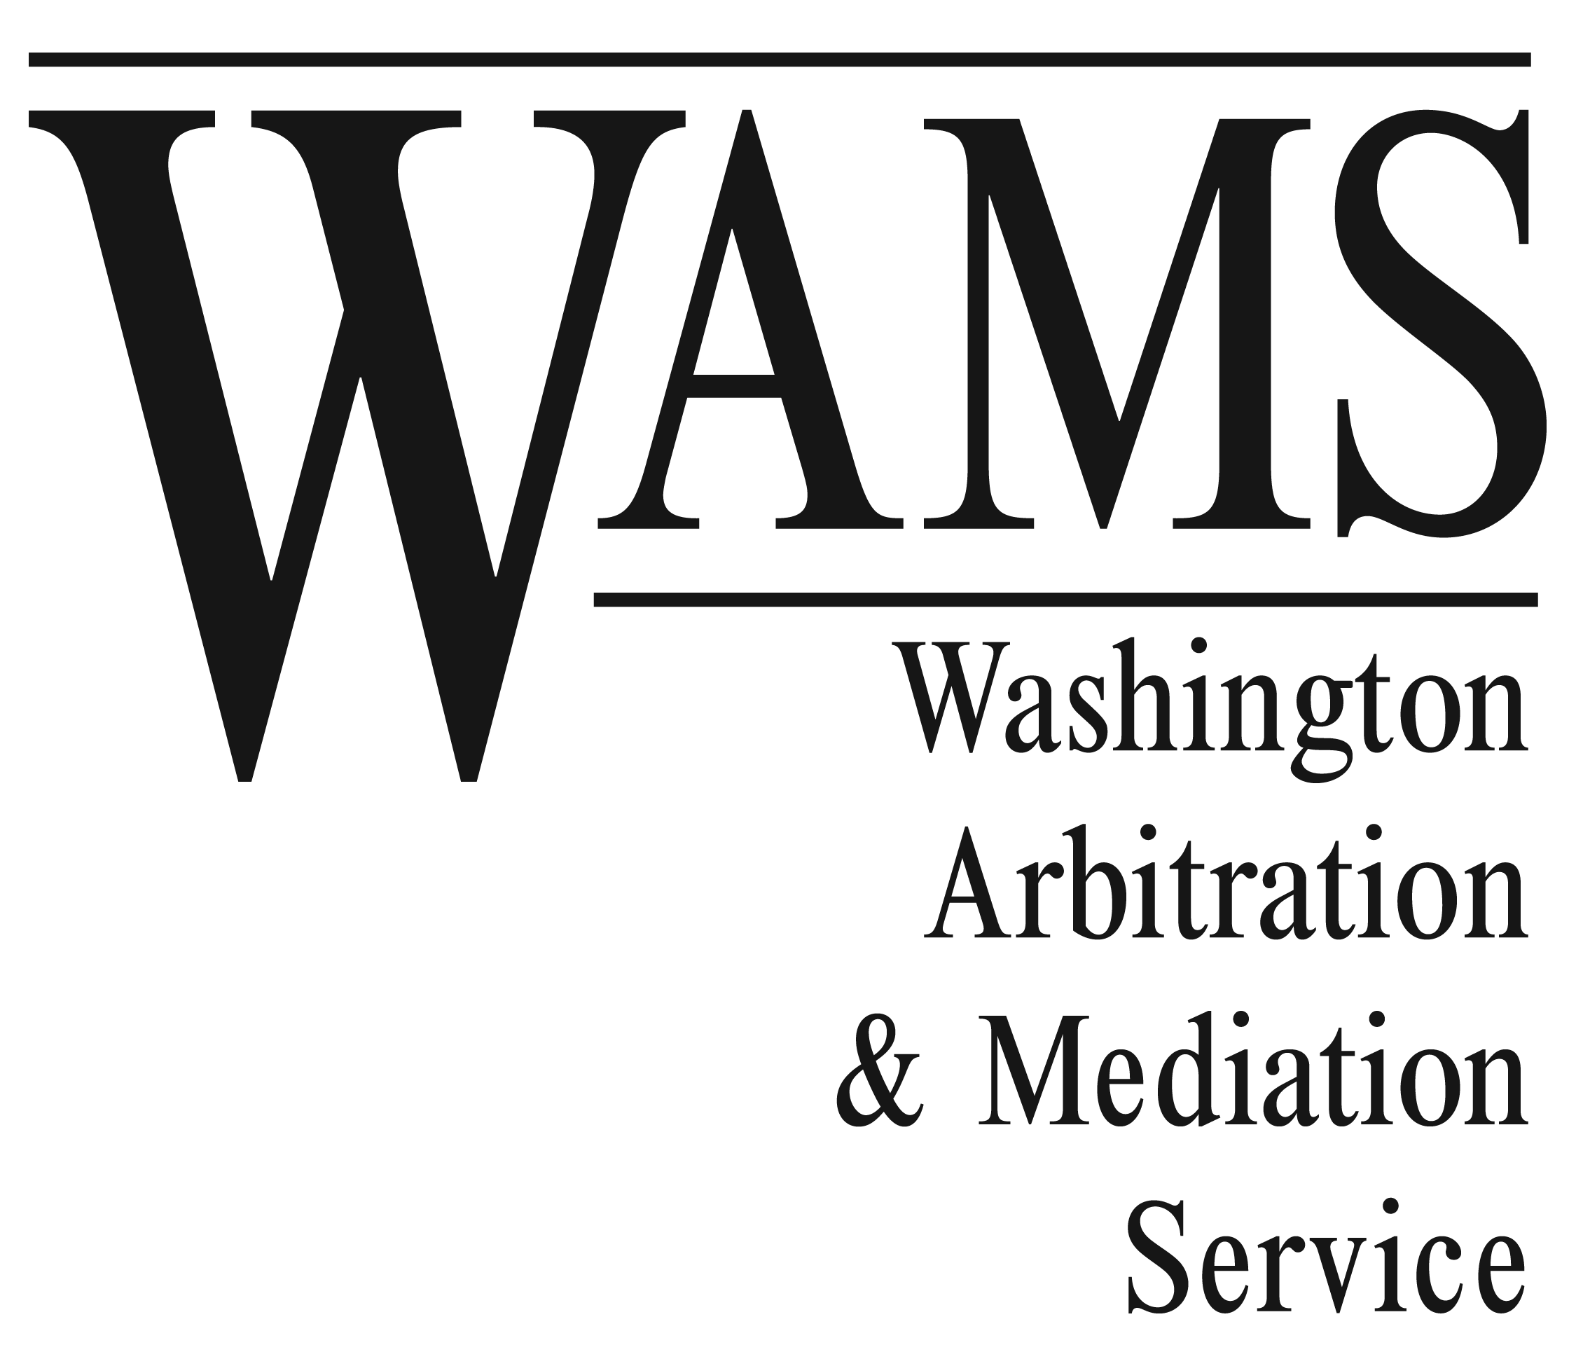
Offices:
600 University Street Suite 900
Seattle, WA 98101
Phone: (206) 467-0793
(800) 933-6348
Fax: (206) 467-7810

3600 Port of Tacoma Road Suite 304
Tacoma, WA 98424
Phone: (253) 922-4140
Fax: (253) 922-5510

WAMS Policies re Confidentiality of Client Submissions

To ensure that WAMS and its affiliated neutrals are in compliance with our client firms’ Business Associate Agreement (“BAA”) confidentiality requirements, listed below is what WAMS and its affiliated neutrals (referred to as “subcontractor” in most BAAs) are required to do (or not do) after materials are submitted for proceedings:

- WAMS and its subcontractor neutrals will use and maintain appropriate administrative, physical and technical procedures to safeguard all Protected Health Information (PHI) provided to WAMS neutrals as subcontractors in WAMS proceedings.

- Materials submitted for WAMS proceedings cannot be duplicated, forwarded, reproduced or otherwise distributed to third parties by WAMS or its subcontractor neutrals without the express authorization of the submitting party or its representative(s).

- Electronic correspondence from WAMS and its subcontractor neutrals must contain a confidentiality clause to help protect PHI from being sent to unauthorized recipients.

- WAMS will advise a party immediately of any erroneous disclosure of PHI and take corrective action as needed to mitigate any harmful effects of such disclosure.

- WAMS and its subcontractor neutrals will not cooperate (except as required by law) with efforts to subpoena or obtain records, notes or work product of WAMS proceedings.

- WAMS and its subcontractor neutrals will not provide PHI to another party participating in a WAMS proceeding unless directed to do so by the individual authorized to distribute the PHI.

- Unless specifically asked by a party to return its materials containing PHI (at the party’s expense), it is the policy of WAMS and its subcontractor neutrals to dispose of said materials via shredding service provided in the neutral’s or Seattle WAMS office.

- Each WAMS subcontractor neutral and employee has agreed to abide by the policies and restrictions set forth herein.

On behalf of Washington Arbitration: ______________________________________________________________________
& Mediation Service I, Inc. Date

This document may be provided to any party as evidence of the WAMS internal policies for safeguarding PHI. Vers.1.3

